Mobile Money Networks
# Source: AI Source: Provided by: [Data Path: Persons Table -> ID Column: 1, Name_En Column: Motasem Essam] -> From: [ChatGPT] on [1/21/2026]
Mobile Money Networks are settlement systems that enable financial transactions using mobile phones — without needing a traditional bank account. These networks support peer-to-peer transfers, merchant payments, utility bills, and wallet-to-bank settlements.
They are especially popular in regions where bank access is limited, but mobile penetration is high.

🧠 Simple Definition
# Source: AI Source: Provided by: [Data Path: Persons Table -> ID Column: 1, Name_En Column: Motasem Essam] -> From: [ChatGPT] on [1/21/2026]
A Mobile Money Network is a telecom-powered payment infrastructure that allows users to store, send, and receive money using mobile wallets — and handles settlement between users, merchants, and banks.

📦 What Mobile Money Networks Do
# Source: AI Source: Provided by: [Data Path: Persons Table -> ID Column: 1, Name_En Column: Motasem Essam] -> From: [ChatGPT] on [1/21/2026]
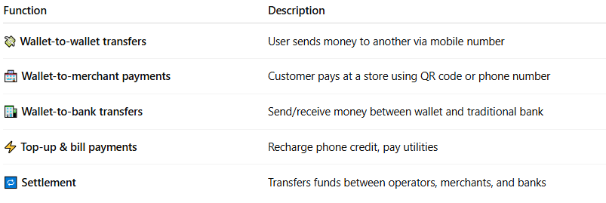

Function | Description
💸 Wallet-to-wallet transfers | User sends money to another via mobile number
🏪 Wallet-to-merchant payments | Customer pays at a store using QR code or phone number
🏦 Wallet-to-bank transfers | Send/receive money between wallet and traditional bank
⚡ Top-up & bill payments | Recharge phone credit, pay utilities
🔁 Settlement | Transfers funds between operators, merchants, and banks

🔄 How Settlement Works in Mobile Money
# Source: AI Source: Provided by: [Data Path: Persons Table -> ID Column: 1, Name_En Column: Motasem Essam] -> From: [ChatGPT] on [1/21/2026]
- User A sends money to User B using a mobile app or USSD code.
- The transaction is recorded instantly in the mobile wallet system.
- The Mobile Money Provider (e.g., Vodafone Cash, M-Pesa) ensures the ledger is updated.
- If cross-operator or bank transfer:
  - Settlement occurs via an interbank connection, or
  - Via aggregators or central switch (e.g., Meeza, InstaPay)
- Final funds are reconciled and settled between financial entities.

🌍 Popular Mobile Money Networks
# Source: AI Source: Provided by: [Data Path: Persons Table -> ID Column: 1, Name_En Column: Motasem Essam] -> From: [ChatGPT] on [1/21/2026]
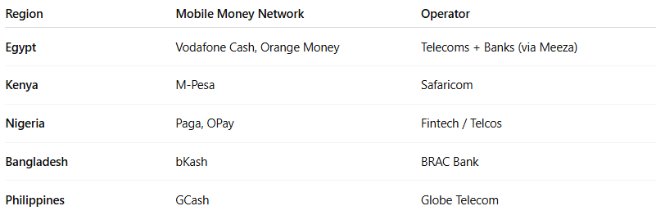

Region | Mobile Money Network | Operator
Egypt | Vodafone Cash, Orange Money | Telecoms + Banks (via Meeza)
Kenya | M-Pesa | Safaricom
Nigeria | Paga, OPay | Fintech / Telcos
Bangladesh | bKash | BRAC Bank
Philippines | GCash | Globe Telecom

📊 Types of Mobile Money Settlement
# Source: AI Source: Provided by: [Data Path: Persons Table -> ID Column: 1, Name_En Column: Motasem Essam] -> From: [ChatGPT] on [1/21/2026]
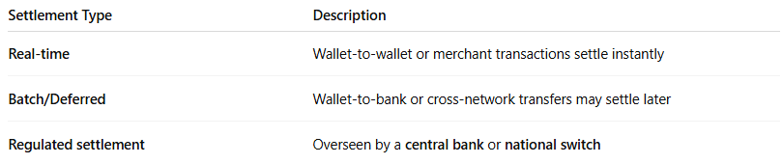

Settlement Type | Description
Real-time | Wallet-to-wallet or merchant transactions settle instantly
Batch/Deferred | Wallet-to-bank or cross-network transfers may settle later
Regulated settlement | Overseen by a central bank or national switch

🔐 Security and Regulation
# Source: AI Source: Provided by: [Data Path: Persons Table -> ID Column: 1, Name_En Column: Motasem Essam] -> From: [ChatGPT] on [1/21/2026]
- Regulated by central banks (e.g., CBE in Egypt)
- Uses KYC/AML checks for wallet registration
- Encrypted and PIN/OTP-protected transactions
- May use tokenized APIs for third-party integrations

✅ Benefits of Mobile Money Networks
# Source: AI Source: Provided by: [Data Path: Persons Table -> ID Column: 1, Name_En Column: Motasem Essam] -> From: [ChatGPT] on [1/21/2026]
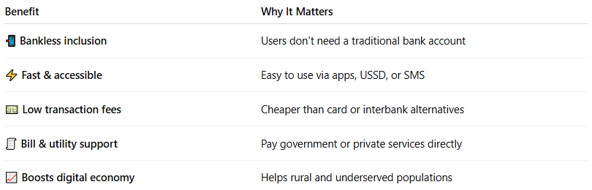

Benefit | Why It Matters
📲 Bankless inclusion | Users don't need a traditional bank account
⚡ Fast & accessible | Easy to use via apps, USSD, or SMS
💵 Low transaction fees | Cheaper than card or interbank alternatives
🧾 Bill & utility support | Pay government or private services directly
📈 Boosts digital economy | Helps rural and underserved populations

🧠 Summary
# Source: AI Source: Provided by: [Data Path: Persons Table -> ID Column: 1, Name_En Column: Motasem Essam] -> From: [ChatGPT] on [1/21/2026]
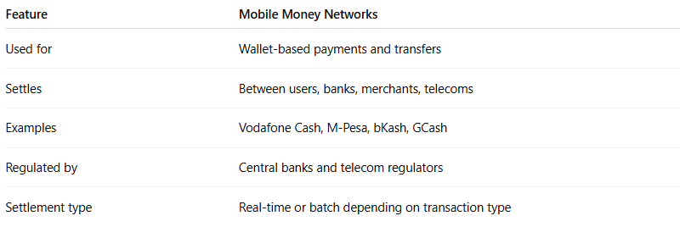

Feature | Mobile Money Networks
Used for | Wallet-based payments and transfers
Settles | Between users, banks, merchants, telecoms
Examples | Vodafone Cash, M-Pesa, bKash, GCash
Regulated by | Central banks and telecom regulators
Settlement type | Real-time or batch depending on transaction type

